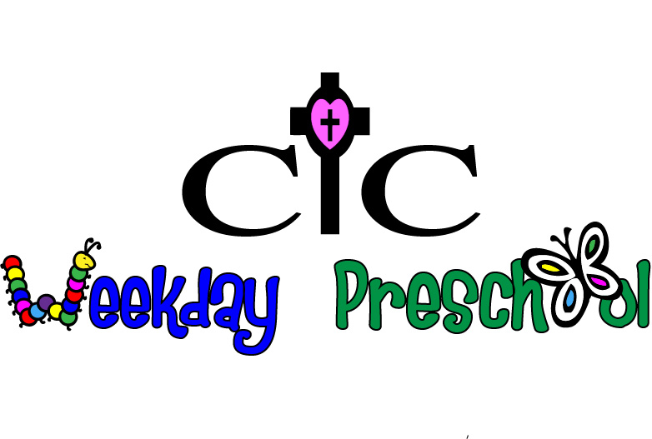

2020 Summer Camp Information
Summer Camp Sessions $130 per session

Session #1-June 1-4 (9:05-1:00)- “Paint, draw, sculpt”-Our little artists will express themselves and their creative side through a variety of art projects. We’ll explore the messier side of art by working with watercolors, finger painting, chalk, clay, and so much more! We will create new masterpieces each day, both indoor and outdoor creations!
$65 registration fee $65 balance due May 14th

Session #2-July 6-9 (9:05-1:00)- “Animal Adventures”-Our campers will go on a safari to learn all about the beautiful and sometimes strange animals in the world. We’ll sample animal-themed crafts, books and games and then venture outside to learn about the critters that dwell in our preschool back yard.
$65 registration fee $65 Balance due June 18th

Session #3-August 3-6 (9:05-1:00)- “Wee Rock”-Our campers will have the opportunity to sing, play instruments and investigate with various types of music, including rock, pop, classical and more! We will even teach our aspiring musicians how to make instruments from household items. $65 registration fee $65 Balance due July 23rd

Summer fun facts:
- Each camp session is $130 with a $65 non-refundable registration fee that will hold your child’s spot in the camp. This fee will be applied to the total camp cost and the balance of $65 for each camp is due 2 weeks prior to that camp.
- All students who fit in the age ranges of 2-5 years old are eligible to attend our summer camps, including children who do not attend CIC Preschool during the regular preschool year.
- Enrollment is first come first served, until camps are filled.
- All summer camp sessions will have an 8x1 ratio.
- All children should wear comfortable play clothes and bring a lunch and drink each camp day. Snack will be provided.
- A completed registration form is needed for each child with checks made payable to CIC Preschool. After registration payment has been received, we will confirm all camp information by email. CIC Preschool reserves the right to cancel any camp and return registration fee for any camp with a low enrollment.

